Name: Oscar Boateng Acheampong

Date: October 20th, 2022

Assignment No: Assignment 1.2 – GitHub Repository Setup

Link to repository: <https://github.com/dboat10/csd-310.git>

Git Repository:

Module 1 git repo:

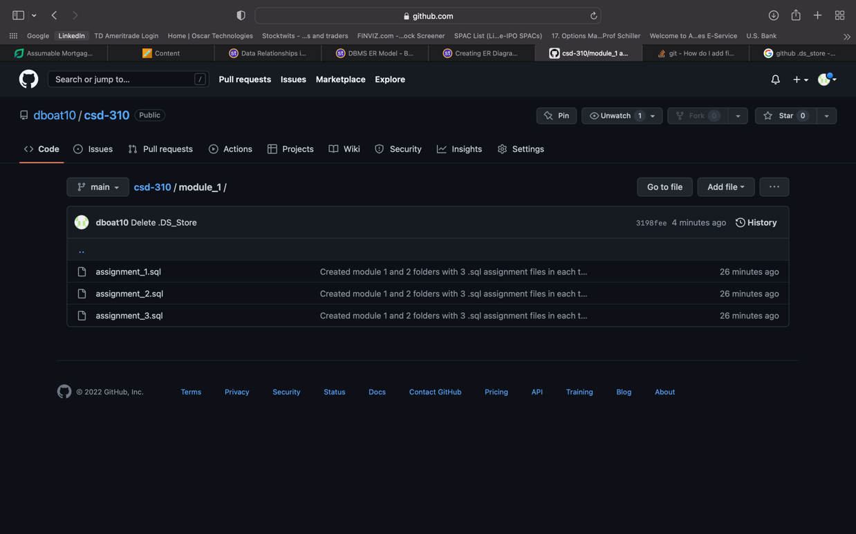

Module 2 git repo:

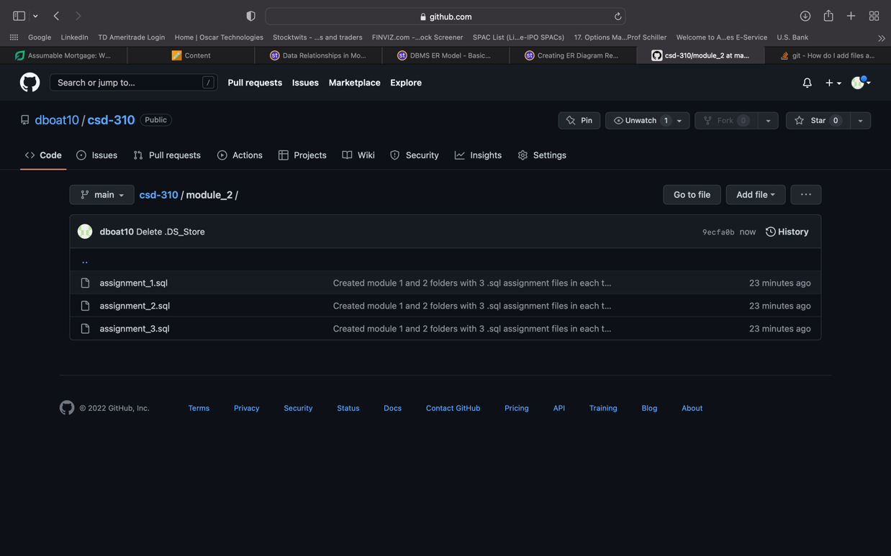

For the local directory, I have an Academics folder, where I gather all my academic documents and, in that folder, I have a folder for csd-310, I created the new csd directory in the csd-310 folder and cloned the git repository there to have my academic files organized in one place.

Local directory:

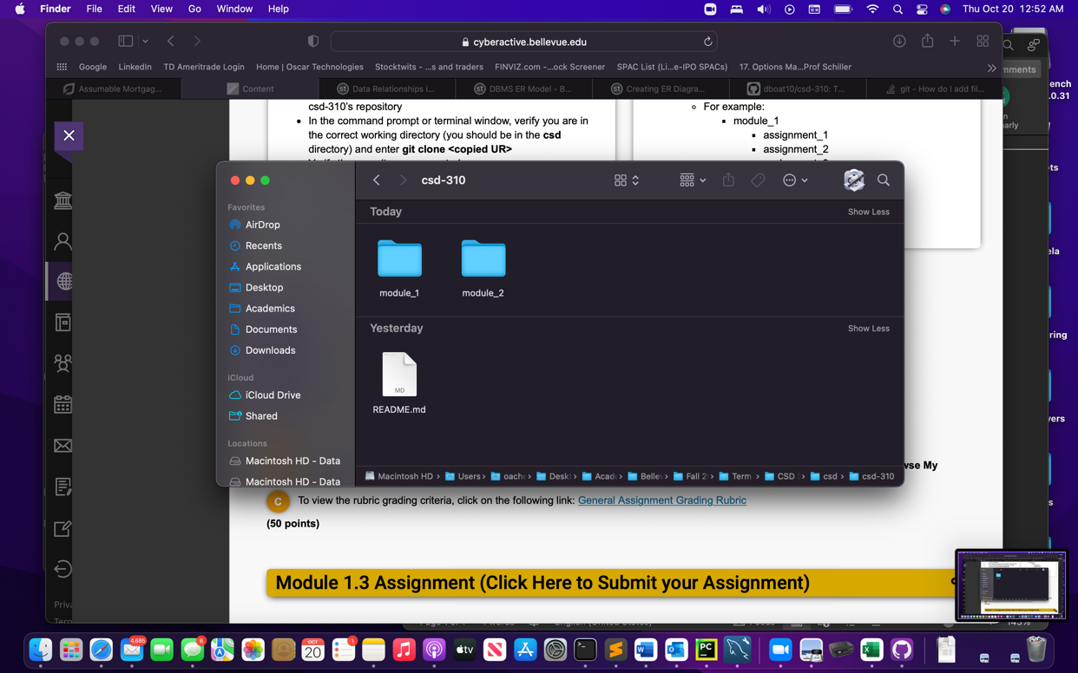

Bonus: CLI image of git commands, this was interested to research and learn since I am a TFS guy and do not use git at work.

